Laboratory Activity 1

Creating a Simple Web Page
Objectives:
At the end of this activity, the students are expected to:
- Start and familiarize the VS Code IDE
- Start and quit the web browser
- Draw, label and identify the basic parts of the VS Code
- List down the functions of the parts of the VS Code
- Enter and use HTML, HEAD, TITLE and body tags correctly
- Create a simple web page
- Save the HTML file
- View the HTML file in the web browser
- Identify and correct simple HTML programming errors

Discussion:
- HTML in Visual Studio Code (VS Code)
  - Visual Studio Code is a code editor with a familiar interface shared by many modern development tools. The left side of the window contains a sidebar for navigating project files and folders, while the right side features the editor pane where the contents of the application files are displayed. Read the following guide as an overview of using HTML in VS Code: https://code.visualstudio.com/docs/languages/html
  - Familiarize the VS Code interface.
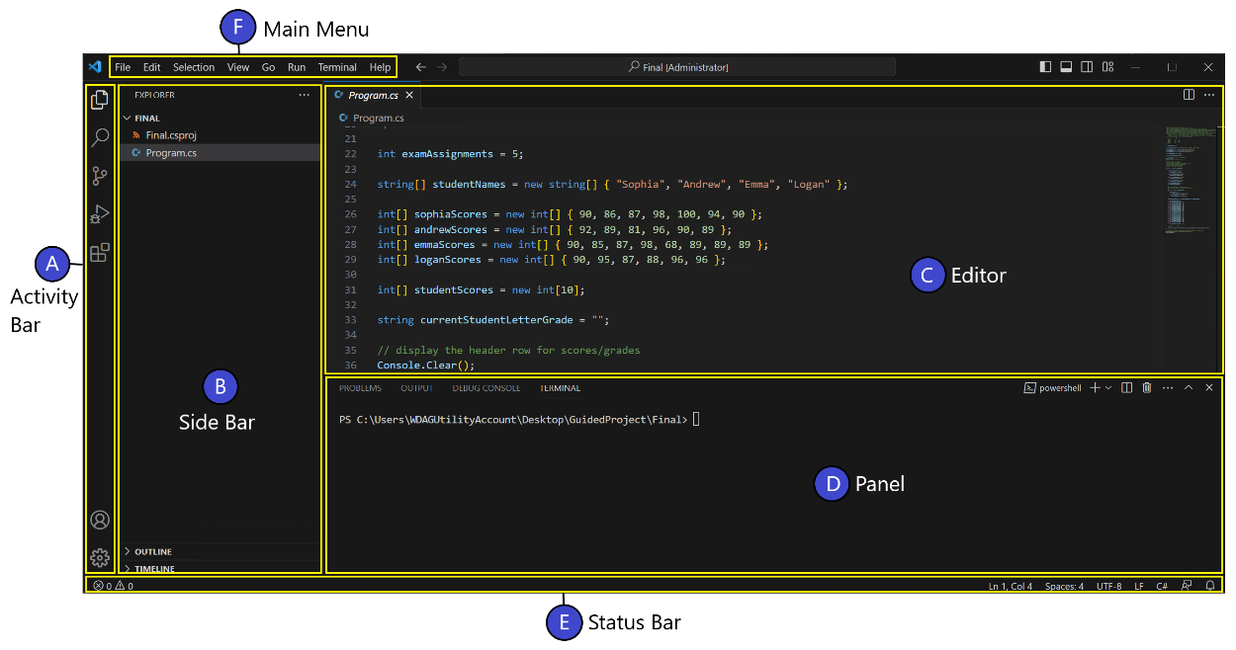
- Activity Bar
The Activity Bar is the narrow vertical bar on the far left of the window. It lets you switch between different views, such as Explorer and Extensions.
- Side Bar
The Side Bar shows tools and resources, such as the file explorer. It helps you manage and navigate your project files.
- Editor
The Editor is where you write and edit your code. You can open multiple files side by side, either vertically or horizontally.
- Panel
The Panel appears below the editor and shows output, errors, debug information, and the integrated terminal.
- Status Bar
The Status Bar is the bar at the bottom of the window. It displays information about the current project and the file you are editing.
- Main Menu
The Main Menu is located at the top of the window. It provides options to save, edit, run your code, and access other features.

Entering HTML Tags and Text

HTML is not case sensitive, uppercase, lowercase letters or combination of both is treated as the same. To adhere standard practice HTML development, we will use the uppercase letters when writing HTML tags. Table 1 list down the basic HTML tags as well as their functions.

Table 1. HTML Tags and Their Functions

HTML Tags | Function
<HTML></HTML> | Indicates the beginning and end of an HTML development
<HEAD></HEAD> | Indicates the beginning and end on the document used for the title and other document header information
<TITLE></TITLE> | Indicates the beginning and end of the title. Please take note that the title does not display in the body of the Web page, but displays  on the title bar of the browser
<BODY></BODY> | Indicates the beginning and end of the web page body
<HN></HN> | Indicates the beginning and the end of the text section called  heading; size ranges from <H1> through <H6>
<P></P> | Indicate the beginning of a new paragraph; inserts a blank line  above the new paragraph
<UL<</UL> | Indicates the beginning and the end of an unordered (bulleted) list
<LI></LI> | Indicates that the item that follows the tag is an item within a list
<HR> | Inserts a horizontal rule
<BR> | Breaks a line of text at the point where the tag appears

Entering Headings in an HTML Tag

Headings serve to separate text and introduce new topics on Web pages. The heading tags used for this purpose vary in size. The size ranges from <H1> through H<6>, with <H1> being the largest. Figure 1.3 displays the various sizes of headings. For consistency and to maintain a good look to your Web page, use the same sized heading for the same level of topic.

Your main heading may contain the name of business or school, or the main idea of the web page. Users usually have only one (1) tag on each Web Page.

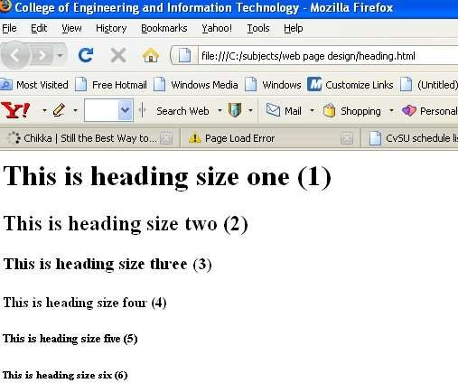

Figure 1. HTML Heading Sizes

Entering Text in Paragraph Format

Web pages contain significant amount of text usually in paragraph format. The <P> tag is one of the few tags that did not originally have corresponding ending tags. Newer versions of HTML added </P> tag, but it is optional. When the Web browser finds </P> tag, it starts a new line and adds some additional vertical spaces between the line that it just displayed and the

following lines. This gives enough of a break in the text to indicate that there is a new paragraph. It is good habit to enter large sections having paragraph breaks.

Creating a List
Lists structure the text in an outline format instead in paragraph format. It helps itemize the information on the web page.
Two Types of List
- Unordered List

- Ordered List
 Also known as the bulleted list
 Formats information as bullet points
 The <UL> and </UL> must be at the beginning and end of this list
 Users can use disc, square or circle as bullets in this list
 By default, the disc is used

 Also known as the numbered list
 Information is shown as numbered or lettered points
 The <0L> and </0L> must be at the beginning and end of this list
 Users can create an ordered list using numbers, letters or roman

numerals  The default option is to number the list Note:
To change the bullet or number type, use the TYPE attribute within the <OL> or <UL> tags. The tag could be <UL TYPE = “disc” or <OL TYPE=" 1“) where the selected type is found within the quotes. The <LI> and </LI> tags define a list item within the ordered and unordered list. Remember that each item within the list has <LI> tag in front of it and </LI> tag at the end.
Please refer to figures 2 and 3 for various types of ordered and unordered list.
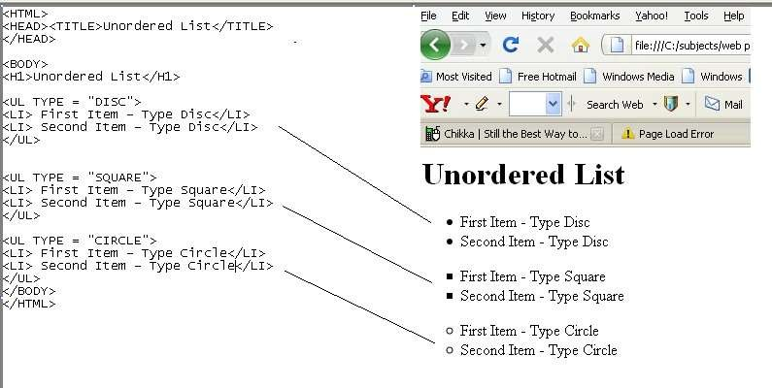

Figure 2. Various Types of Unordered List

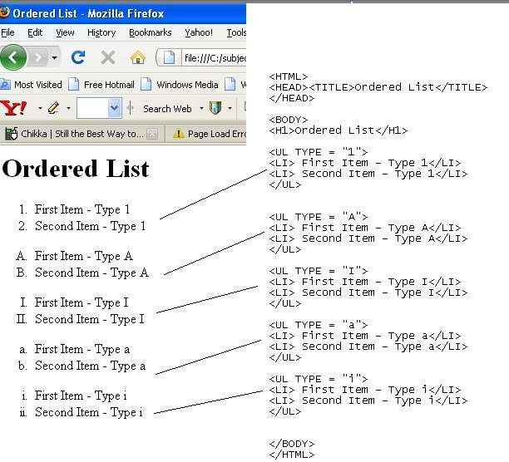

Figure 3. Various Types of Ordered List

Procedure:

Entering Initial HTML Tags

- In your VS Code, type <HTML> and then press the Enter Key.
- Type <HEAD> and then press the Enter key
- Type <TITLE> Computer Technician </TITLE> and then press the Enter key
- Type </HEAD> and then press the Enter key.
- Type <BODY> and then press the Enter key twice.
- Type </BODY> and then press the Enter key.
- Type </HTML> as the tag.

To create the Web page heading:
- Click the blank line below <BODY> type <H1> What is a Computer Technician ?</H1> and then press the enter key.

To enter text in paragraph format:

With the insertion point on line 7, type <P> A computer technician is a person who repairs and maintains computers and servers. The technician’s responsibilities may extend to include building or configuring new hardware, installing and updating software packages, and creating and maintaining computer networks. Computer repair technicians work in a variety of settings, encompassing both the public and private sectors. Because of the relative newness of the profession, institutions offer certificate and degree programs designed to prepare new technicians, but computer repairs are frequently performed by experienced and certified technicians who have little formal training in the field </P> and then press the Enter key

Creating a Bulleted List

- With the Insertion Point at line 11, type <H2> What steps do I need to follow to become a computer technician?</H2> and then press the Enter key
- Type <UL> and then press the Enter key
- Type <LI>Learn about computers </LI> and then press the Enter key
- Type <LI>Gain experience</LI> and then press the Enter key
- Type <LI>Get formal computer training </LI> and then press the Enter key
- Type <LI>Obtain certifications </LI> and then press the Enter key
- Type the </UL> tag

Saving the HTML File
- Save this as exercisel-webpage.html on your folder in the hard disk.

Using the Web Browser to View the HTML File
- Click the Start button on the taskbar and then point to Programs on the Start Menu. Point to the Internet Explorer or your web browser on the Programs submenu.
- Now, open your HTML file. Your screen should at least resemble Figure 4. You've just created your first web page.

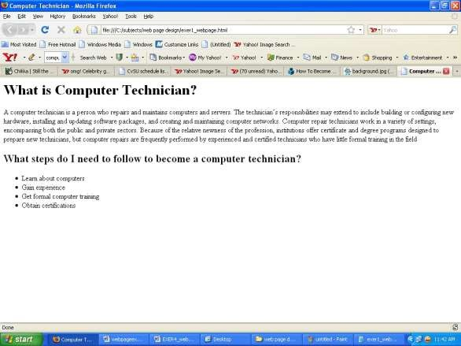

Figure 4 Your First HTML Page

- Now, go back to the VS Code and edit your work by simply trying different sizes of heading. Remember that your heading size ranges from 1 to 6. Use other heading sizes. Use also other bulleted list format such as the circle and square. Save this edited work as exercise1a-webpage.html l 21. View exercise1a_webpage.html on your browser 22. Close and exit your Web Browser and VS Code.
23. Shut down the computer properly.

Conclusion
Write what you have learned from this activity in two to five sentences only.

